Chapter 4, Problem 80.

Use PSpice to find the Thevenin equivalent circuit at terminals a-b of the circuit in Fig. 4.125.

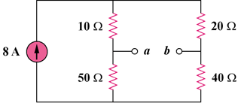

Figure 4.125
For Prob. 4.80.

